That Open Master
Notes from the course

THREE.JS
There is a few things that is always needed when starting to include three.js in the DOM.
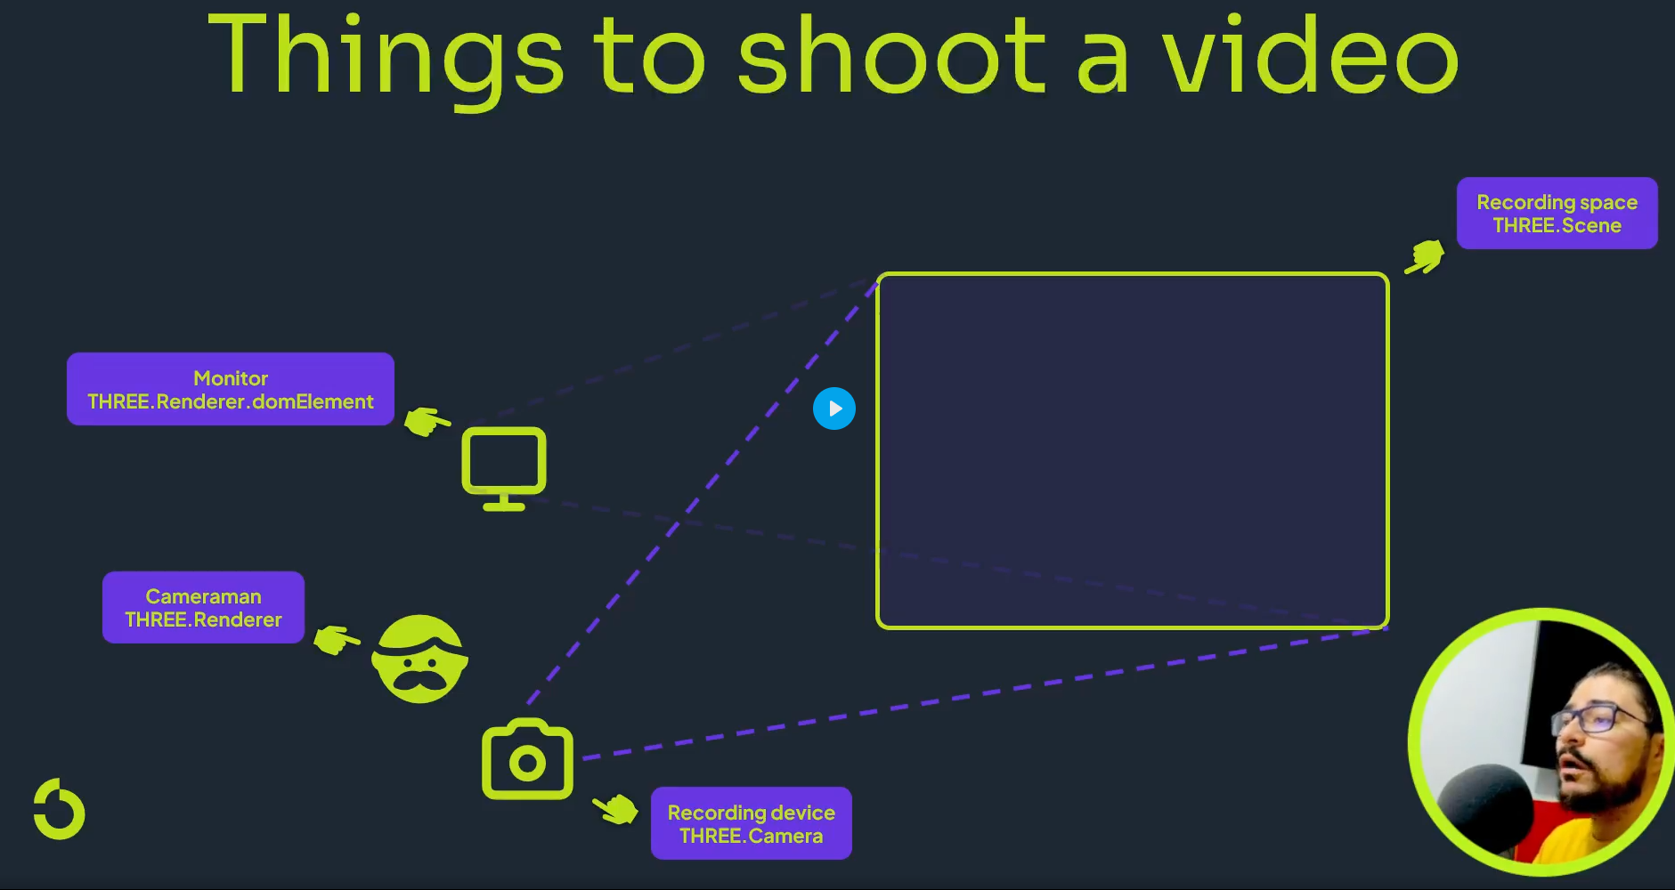
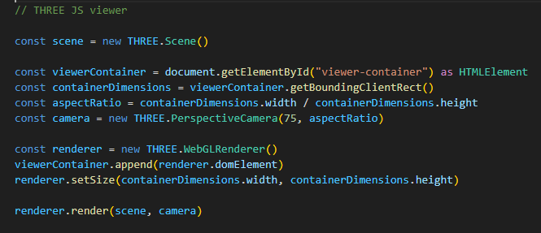
We need a scene where the model will be shown, a camera to show what is there, a camera man (a renderer) to control the camera, and the camera man’s monitor to show everyone in real time the filming. This monitor is the Renderer.domElement. Finally we just need to put the domElement on the viewerContainer.

REACT
React is, as the name implies, a way to make the code more reactive. Every little event that needs to happen is not hard coded, but more included in the code’s functions.
Saving events
For example lets look at the projects page, the page that shows the overview of the different projects. The ProjectsManager class is the class that keeps control over the different projects. So, if we want to create a new event or action, we have to create this event in ProjectsManager as an instance, and call it where it is supposed to be called.
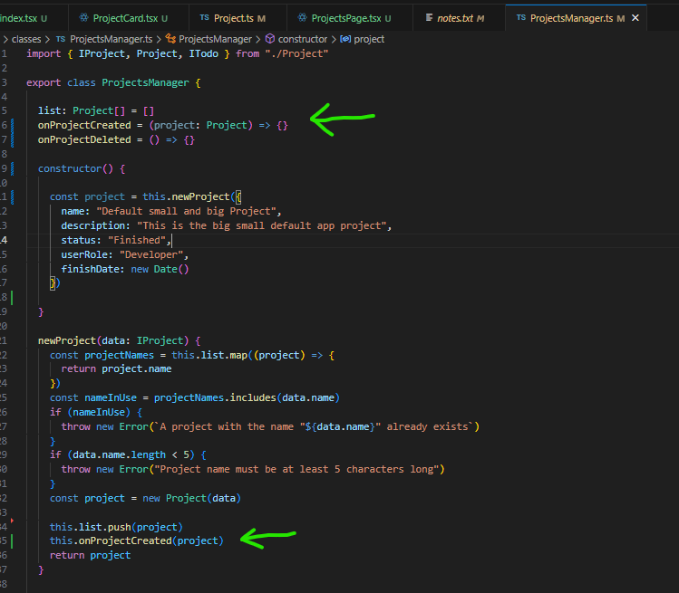
So here in the ProjectsManager class we have now defined an event onProjectsCreated that takes an argument, project of type Project. However, this has no function yet. This function is defined in the ProjectsPage function
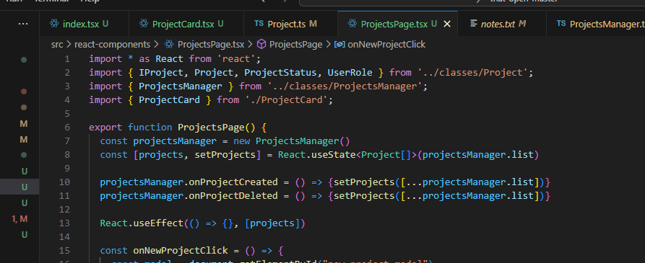
This is great, because using this logic, you can use the onProjectCreated event in different events and give it different logic. In this case there is only one case where projects are created.

The inputs to the function in the react classes are called component properties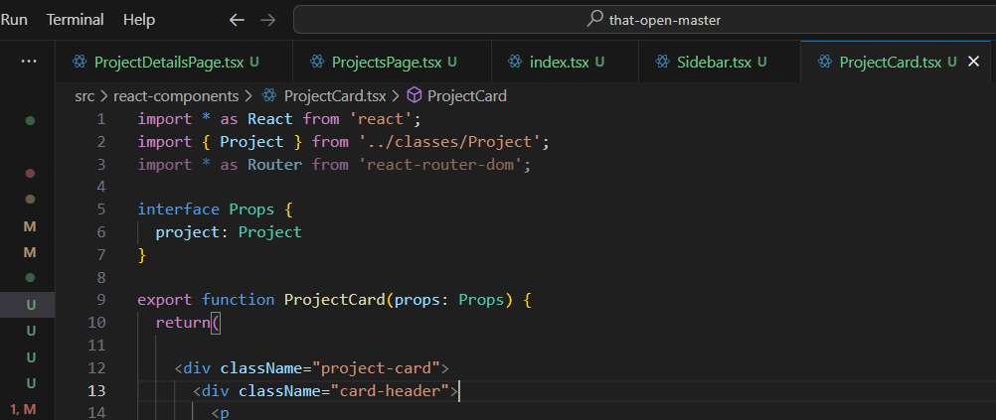

JavaScript syntax
Something that has been confusing me a little is the way that functions are being coded in javascript, when do you write things like () => {} and when not?
Lets take this example:
onClick={() => {props.projectsManager.deleteProject(project.id)}}
we are giving the react component a function for its delete button so it knows what do to if it is clicked. The difference is:
onClick={props.projectsManager.deleteProject(project.id)}
this would delete the project when the component is rendered.

